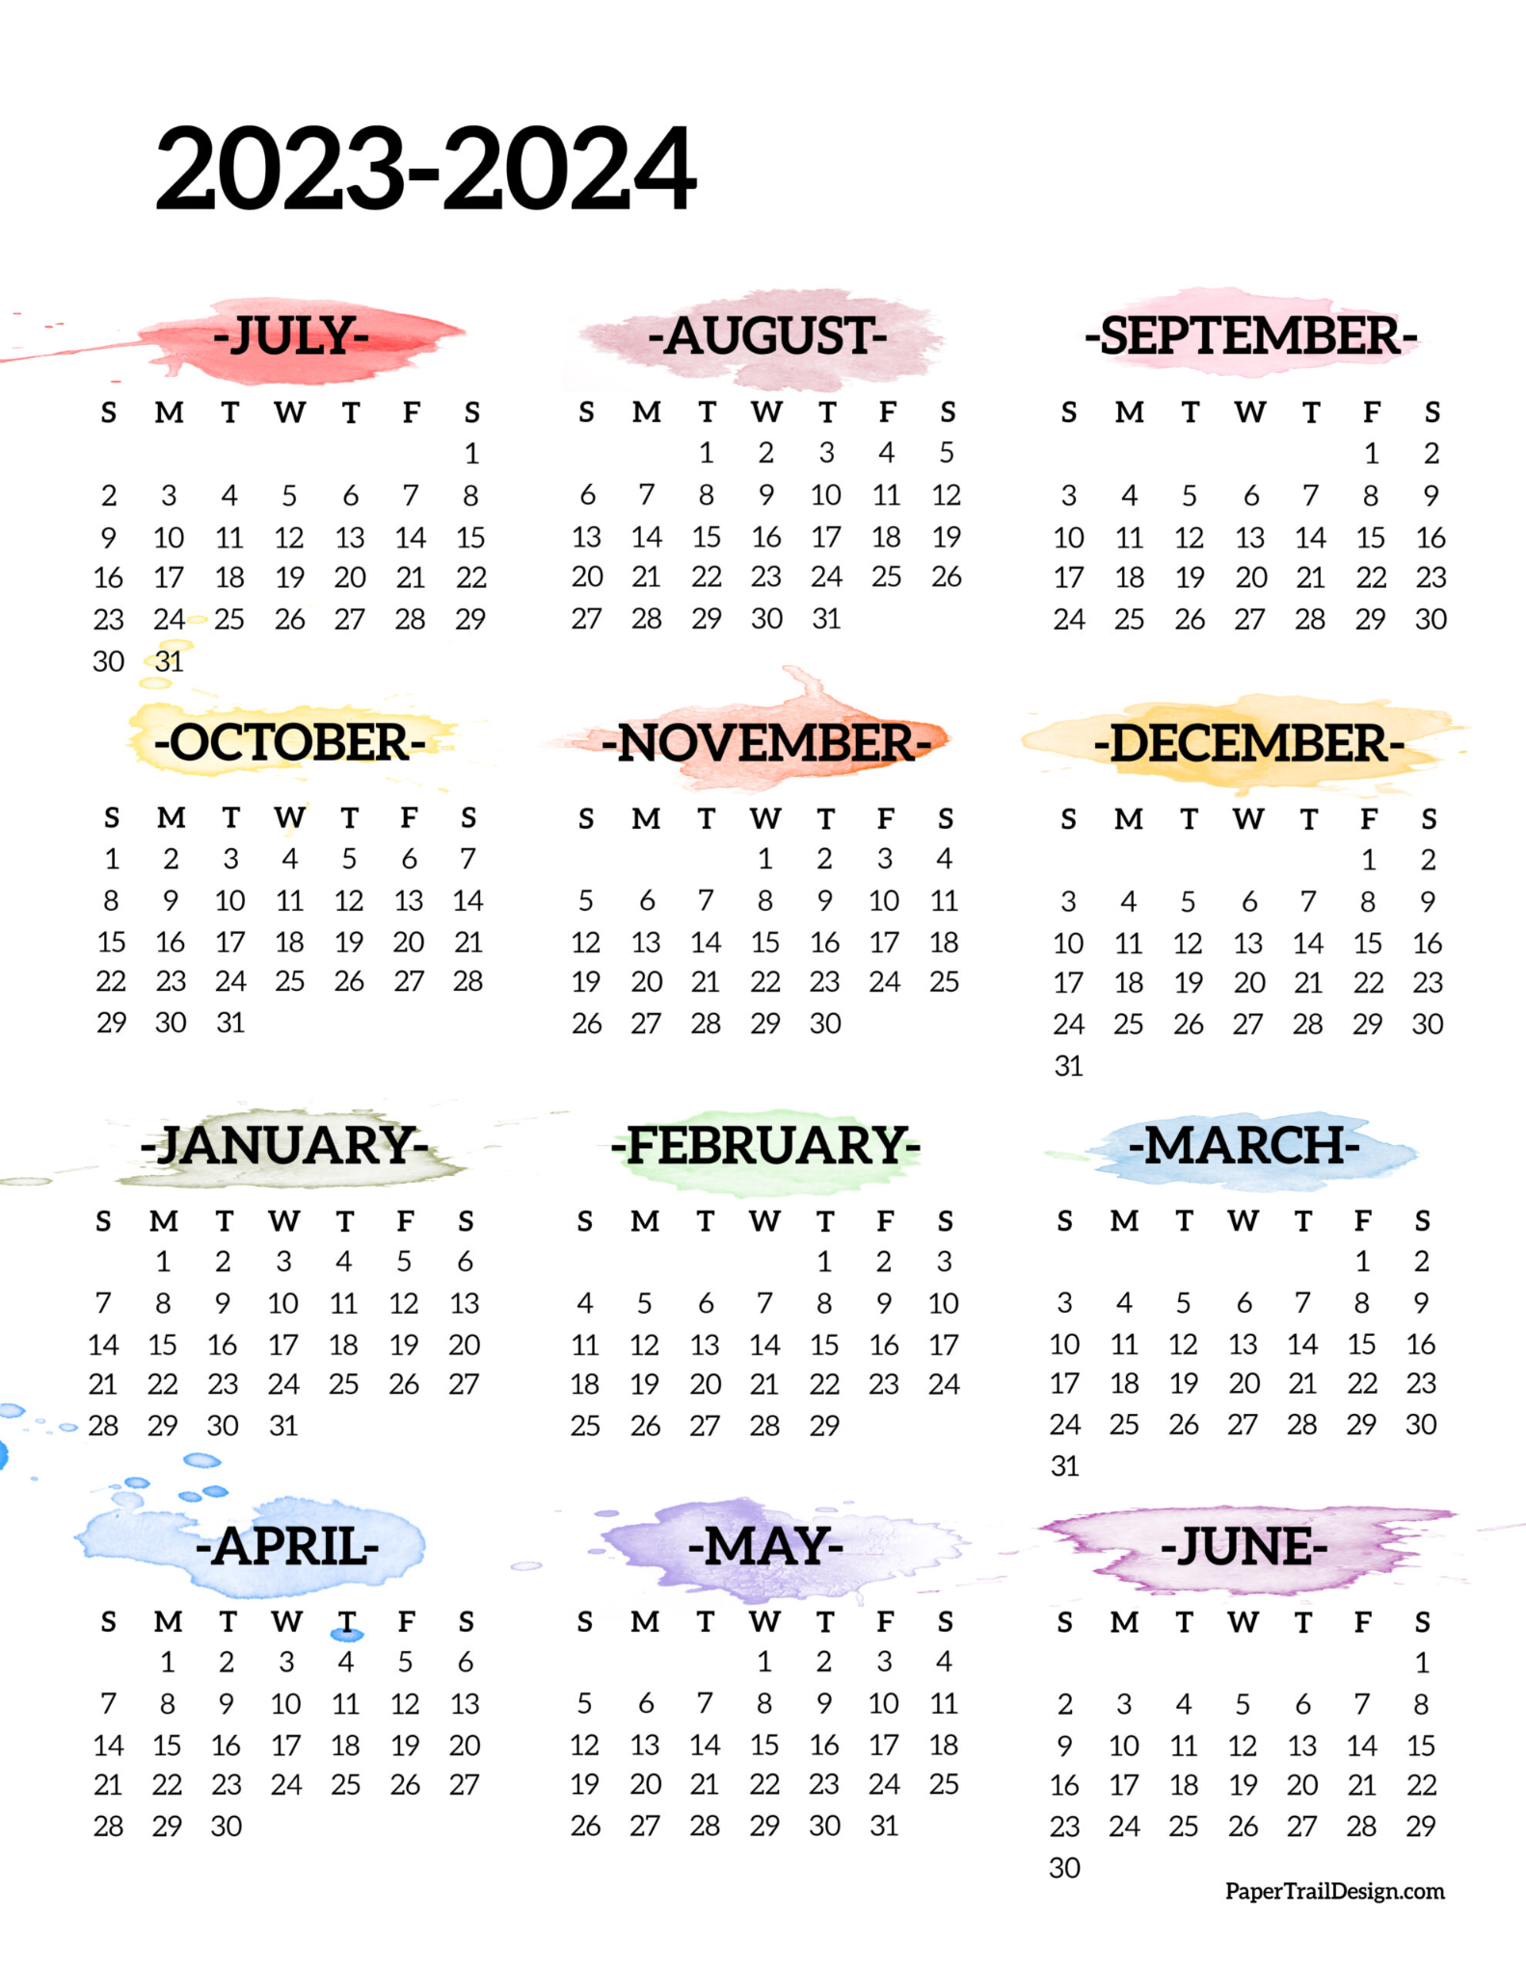

























**2023-2024**

**July August September**

3rd-7th: 1st & 4th: Summer Labor Day

Break Weekend

**October November December**

6th & 9th: Columbus 20th-24th: 25th-29th:

Day Weekend Thanksgiving Christmas

Break Break

**January February March**

1st- New Years 16th & 19th: Presidents 29th: Good

Day Weekend Friday

12th & 15th: Martin

Luther King

Weekend

**April May June**

1st: Easter 24th & 27th: Memorial

Monday Day Weekend